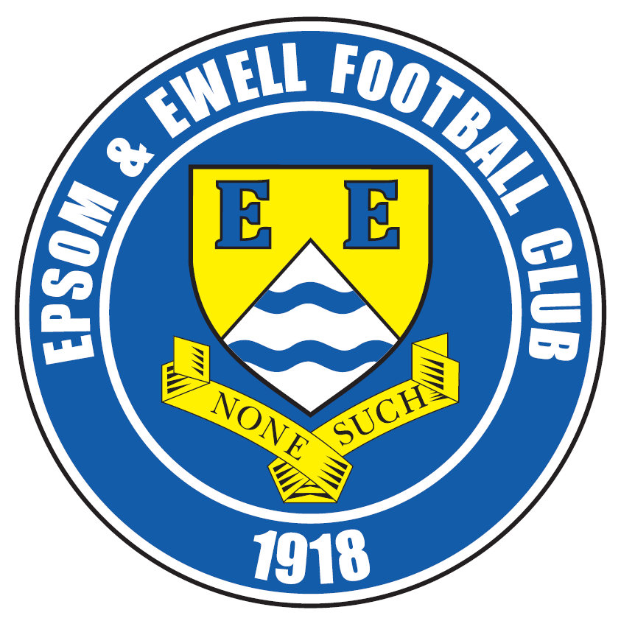 | Epsom & Ewell F.C.  9  v  Sutton Common Rovers  Tuesday, 8th November 2016 – 7.45 p.m.
Good evening! We host Sutton Common Rovers in a League match and welcome their players, officials and supporters and of course our own regular faces.

We first met our opponents in 2010 and since then have played each other at four different venues. Although we drew and lost in our first pair of meetings at Merstham and then at Cobham, we have recorded eight straight wins since then and will obviously be trying to make it nine!

Home matches have been few and far between recently with only one since the 24th September and that was only due to receiving a home draw in the Vase! We will now be playing here quite a lot which is a bit of a nightmare for a Programme Editor. As a result, the next programme will be a double issue, against Abbey Rangers on Sunday in the F.A. Vase and Windsor in the League.

The Abbey match is of course an extremely important one and like our opponents tonight who also have a big match at the weekend it would be easy to dismiss this match as of less importance, but that would be a mistake. Sutton Common Rovers will be at home to Sporting Club Thamesmead, also on Sunday and we wish them well for that match.

But back to tonight’s encounter. After many years where our away form has been stronger than our home form we are showing signs of changing that this season. Currently only the 5-1 home defeat to CB Hounslow United blemishes a very good record and five straight clean sheets have followed our 7-1 League win over Abbey Rangers back in late August. It’s a bit early to start calling it “fortress Chipstead” yet, but if we can negotiate the substantial number of home matches coming up without mishap then we’ll see!

Our last outing here was on 22nd October when we eased past Bridon Ropes by a single goal, which was Craig Hastings’ first for the club. It was not a vintage performance but the opposition rarely looked like scoring and I think we know that we will have to play a little better in the next round. Following that match we required a late Matt Ferdinando free kick to scramble a point at Raynes Park Vale on the Tuesday. We had a number of players missing which didn’t help and trailed for 86 minutes. I wonder if that is a record! We then visited Guildford City after an 11 day break and worked very hard to win 2-0 there with goals from Rob Hendry and Matt Farrell.

Following the Abbey Rangers match we follow that up with a home match against Windsor on Tuesday (assuming no Vase replay) and then Bedfont Sports on Saturday with AFC Hayes here seven days later. That’s five home matches in a row. Let’s target five wins and see how we get on!

Enjoy the game!

Rich

You can follow us on Facebook: www.facebook.com/epsomandewellfc Twitter: @EEFCOfficial and
Instagram at: www.instagram.com/epsomandewellfc We also have a Youtube channel now!

Cover photos by Gemma Jarman

- Jordan Gallagher scores our fourth goal at Hanworth Villa with a fine volley

- Daryl Cooper-Smith is fouled, earning a penalty for our third goal at Hanworth


Cherry Red Records Combined Counties League
Premier Division Table 2016/17
incl Saturday 5th November | P | W | D | L | F | A | Pts | GD | H | A
Hartley Wintney | 19 | 16 | 2 | 1 | 70 | 19 | 50 | +51 | 18/3 | 10/12
Westfield | 17 | 11 | 4 | 2 | 37 | 15 | 37 | +22 | 18/2 | 1-2
Hanworth Villa | 18 | 10 | 3 | 5 | 29 | 24 | 33 | +5 | 13/12 | 14/1
Knaphill | 18 | 10 | 1 | 7 | 38 | 31 | 31 | +7 | 4-0 | 8/4
Walton & Hersham | 15 | 8 | 5 | 2 | 23 | 13 | 29 | +10 | 4/3 | 1-1
Bedfont Sports | 16 | 9 | 2 | 5 | 34 | 30 | 29 | +4 | 19/11 | 7/2
Guildford City | 18 | 8 | 4 | 6 | 45 | 38 | 28 | +7 | 17/1 | 2-0
Camberley Town | 15 | 8 | 2 | 5 | 33 | 17 | 26 | +16 | 0-0 | 1/4
CB Hounslow United | 15 | 8 | 1 | 6 | 30 | 27 | 25 | +3 | 1-5 | 12/11
Epsom & Ewell | 15 | 7 | 3 | 5 | 37 | 23 | 24 | +14 | X | X
Horley Town | 13 | 7 | 2 | 4 | 26 | 20 | 23 | +6 | 3-0 | 17/4
Windsor | 18 | 6 | 5 | 7 | 32 | 32 | 23 | 0 | 15/11 | 1-2
Colliers Wood United | 17 | 6 | 4 | 7 | 30 | 31 | 22 | -1 | 14/4 | 0-5
Spelthorne Sports | 16 | 5 | 5 | 6 | 27 | 26 | 20 | +1 | 7/1 | 25/2
Abbey Rangers | 17 | 6 | 2 | 9 | 23 | 32 | 20 | -9 | 7-1 | 3/12
North Greenford United | 15 | 5 | 4 | 6 | 31 | 29 | 19 | +2 | 22/4 | 1-2
AFC Hayes | 16 | 5 | 2 | 9 | 22 | 29 | 17 | -7 | 26/11 | 28/1
Farnham Town | 16 | 5 | 1 | 10 | 25 | 37 | 16 | -12 | 25/3 | 2-1
Raynes Park Vale | 19 | 4 | 4 | 11 | 25 | 40 | 16 | -15 | 27/12 | 1-1
Sutton Common Rovers | 15 | 4 | 3 | 8 | 17 | 28 | 15 | -11 | 8/11 | 2/1
Chertsey Town | 16 | 4 | 2 | 10 | 15 | 42 | 14 | -27 | 17/12 | 11/2
Badshot Lea | 17 | 3 | 1 | 13 | 20 | 52 | 10 | -32 | 4/2 | 4-1
Bedfont & Feltham | 17 | 2 | 2 | 13 | 16 | 50 | 8 | -34 | 21/1 | 9-2

Lucky Day? – 8th November
Played 14 - W 7 D 2 L 5 - For 28 Against 19 - PPG 1.64 - Above Average
Our Club record against Sutton Common Rovers
Played 10 - W 8 D 1 L 1 - F 27 A 12 - PPG 2.50 - Fantastic
Our Largest wins and losses against our opponent
30th November 2013 - W 4-0 - Combined Counties League (H)
28th April 2011 - L 1-4 - Combined Counties League (A)
Their Last Visit
Saturday 19th December 2016 - W 3-1 - Combined Counties League

First Eleven Appearances 2016/17 - (max 20)
Name | Debut | 2016/17 |  |  |  | Career Totals
Name | Debut | App | Sub | Total | Goals | App | Sub | Total | Goals
CLARK-GLEAVE Charlie | 23/08/2016 | 1 | 2 | 3 | 0 | 1 | 2 | 3 | 0
COOPER-SMITH Daryl | 03/01/2015 | 15 | 1 | 16 | 15 | 45 | 9 | 54 | 35
DEAN Dan | 02/08/2014 | 12 | 1 | 13 | 0 | 80 | 5 | 85 | 2
EACOTT Michael | 02/08/2014 | 16 | 0 | 16 | 0 | 101 | 1 | 102 | 0
FARRELL Matt | 02/08/2014 | 19 | 0 | 19 | 10 | 105 | 4 | 109 | 28
FERDINANDO Matt | 20/09/2014 | 8 | 3 | 11 | 2 | 61 | 9 | 70 | 16
GALLAGHER Jordan | 07/08/2016 | 6 | 11 | 17 | 3 | 6 | 11 | 17 | 3
GRIFFIN Reisse | 08/08/2015 | 18 | 1 | 19 | 2 | 46 | 7 | 53 | 4
HASTINGS Craig | 08/08/2015 | 12 | 5 | 17 | 1 | 49 | 9 | 58 | 1
HEAGNEY Adam | 16/08/2016 | 13 | 2 | 15 | 0 | 13 | 2 | 15 | 0
HENDRY Rob | 08/08/2015 | 13 | 4 | 17 | 3 | 43 | 15 | 58 | 15
MCKAY Alex | 20/12/2008 | 12 | 2 | 14 | 2 | 120 | 32 | 152 | 10
NEALE Tom* | 13/10/2015 | 6 | 5 | 11 | 7 | 22 | 24 | 46 | 17
NORTH Rhys* | 16/08/2015 | 2 | 2 | 4 | 0 | 19 | 9 | 28 | 1
NWACHUKWU Jason | 01/10/2016 | 2 | 3 | 5 | 0 | 2 | 3 | 5 | 0
PANAYIOTOU Savvas | 03/01/2015 | 14 | 3 | 17 | 0 | 46 | 11 | 57 | 7
PRICE Matt* | 23/08/2016 | 2 | 0 | 2 | 1 | 2 | 0 | 2 | 1
ROBINSON Sam* | 22/10/2011 | 7 | 1 | 8 | 1 | 61 | 6 | 67 | 14
ROSE Daniel | 25/10/2016 | 1 | 1 | 2 | 0 | 1 | 1 | 2 | 0
SALEH Mennar* | 24/09/2016 | 0 | 2 | 2 | 0 | 0 | 2 | 2 | 0
SMITH Matt | 08/08/2009 | 0 | 1 | 1 | 1 | 91 | 44 | 135 | 11
TANTON Matt | 02/08/2014 | 17 | 1 | 18 | 0 | 74 | 5 | 79 | 2
TAYLOR James | 26/08/2013 | 16 | 2 | 18 | 0 | 102 | 14 | 116 | 6
THOMPSON Elliott | 09/02/2016 | 3 | 0 | 3 | 1 | 7 | 9 | 16 | 1
TURPIE Alistair | 31/03/2016 | 4 | 1 | 5 | 0 | 6 | 1 | 7 | 0
WATRET Jack* | 02/08/2016 | 1 | 0 | 1 | 0 | 1 | 0 | 1 | 0
* player has left the club

Latest Results and Fixtures
F.A. Vase First Round – Saturday 22nd October
Abbey Rangers | 3-0 | Tunbridge Wells
Bedfont Sports | 5-4 | Buckingham Town
Eastbourne United | 2-0 | Horley Town
Epsom & Ewell | 1-0 | Bridon Ropes
Walton & Hersham | 3-0 | Thame United
Combined Counties League – Saturday 22nd October
CB Hounslow United | 2-1 | Raynes Park Vale
Guildford City | 4-4 | North Greenford United
Hanworth Villa | 2-2 | Bedfont & Feltham
Hartley Wintney | 4-1 | Colliers Wood United
Knaphill | 2-2 | Westfield
Spelthorne Sports | 1-2 | AFC Hayes
Combined Counties League – Monday 24th October
Abbey Rangers | 1-0 | Farnham Town
Combined Counties League – Tuesday 25th October
Hanworth Villa | 3-7 | North Greenford United
Hartley Wintney | 4-3 | Spelthorne Sports
Raynes Park Vale | 1-1 | Epsom & Ewell
Combined Counties League – Wednesday 26th October
Bedfont Sports | 2-2 | Windsor
Colliers Wood United | 2-1 | Chertsey Town
Guildford City | 2-7 | Horley Town
Combined Counties League – Saturday 29th October
Abbey Rangers | 0-2 | Horley Town
AFC Hayes | 0-2 | Farnham Town
Bedfont & Feltham | 1-0 | Windsor
Camberley Town | 1-3 | Bedfont Sports
Chertsey Town | 1-2 | Guildford City
North Greenford United | 2-1 | Spelthorne Sports
Raynes Park Vale | 1-2 | Hanworth Villa
Sutton Common Rovers | 1-2 | CB Hounslow United
Walton & Hersham | 2-0 | Badshot Lea
Westfield | 1-1 | Hartley Wintney
Combined Counties League – Monday 31st October
Sutton Common Rovers | 2-1 | Badshot Lea
Combined Counties League Cup – Second Round – Tuesday 1st November
Walton & Hersham | 5-1 | Eversley & California
Westfield | 8-4+ | Redhill
Latest Results and Fixtures
Combined Counties League Cup – Third Round – Tuesday 1st November
Ash United | 0-2 | Windsor
Horley Town | 2-0 | Chessington & Hook United
Raynes Park Vale | 2-1 | Hartley Wintney
Combined Counties League Cup – Third Round – Wednesday 2nd November
Guildford City | 2-1 | Balham
Combined Counties League – Saturday 5th November
AFC Hayes | 1-3 | Camberley Town
Badshot Lea | 2-4 | CB Hounslow United
Bedfont & Feltham | 1-2 | Sutton Common Rovers
Colliers Wood United | 1-2 | Abbey Rangers
Guildford City | 0-2 | Epsom & Ewell
Hanworth Villa | 3-0 | Chertsey Town
Hartley Wintney | 7-0 | North Greenford United
Horley Town | 2-1 | Bedfont Sports
Knaphill | 2-1 | Walton & Hersham
Spelthorne Sports | 2-2 | Raynes Park Vale
Windsor | 1-3 | Westfield
Combined Counties League – Monday 7th November
Abbey Rangers | V | Knaphill
Combined Counties League – Tuesday 8th November
Camberley Town | V | Guildford City
Epsom & Ewell | V | Sutton Common Rovers
Combined Counties League – Wednesday 9th November
Colliers Wood United | V | Horley Town
Buildbase F.A. Vase – Second Round – Saturday 12th November
Highworth Town | V | Knaphill
Bedfont Sports | V | Haywards Heath Town
Camberley Town | V | Southall
Hartley Wintney | V | Melksham Town
Walton & Hersham | V | Glebe
Combined Counties League – Saturday 12th November
AFC Hayes | V | Colliers Wood United
Badshot Lea | V | Spelthorne Sports
Chertsey Town | V | Bedfont & Feltham
Farnham Town | V | Guildford City
Horley Town | V | North Greenford United
Raynes Park Vale | V | Westfield
Windsor | V | Hanworth Villa

From behind the goal
Epsom & Ewell 1 - 0 Bridon Ropes
Buildbase F.A. Vase – First Round - Saturday 22nd October 2016

Hastings unties the Ropes to ensure Vase progress

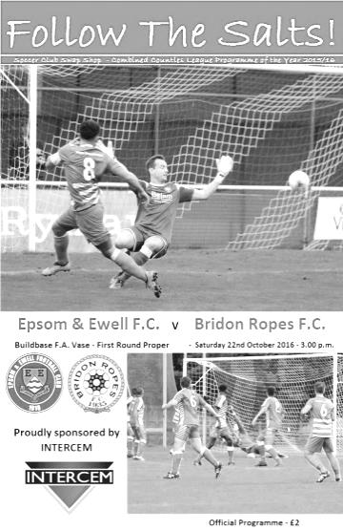
A near post set piece delivered by Savvas ‘Agi’ Panayiotou and headed in by Craig Hastings proved to be the difference between the two sides on Saturday as we made it to the Second Round of the F.A.Vase for the first time since we were exempted there in 2010. That day we defeated Bracknell Town by four clear goals and until this result it was the last time we had won a home Vase match, so it's fair to say it was due.

It's also fair to say that this wasn't the most glowing of performances from our boys and in reality, the first twenty minutes apart, the remainder of the game was largely unmemorable, although not for Hastings who will always remember his first goal for the club after a succession of near misses and unfortunate decisions against him during his time here.

After our late loss at North Greenford United both Matt Farrell and Matt Tanton were back in the starting line up, allowing both Panayiotou and Reisse Griffin to play further forward once again at the expense of Jason Nwachukwu and Rob Hendry who were on the bench. It was good to see such a strong bench with five viable options today and such was its strength that neither Nwachukwu nor Hendry even got on the pitch today. Hastings came in for James Taylor at the back, but no mention of the line up would be complete without reference to Alex McKay who became the 57th player in club history to make his 150th appearance, although it won't be remembered for any more than a headache after a clash of heads just before half time left him requiring replacement very early in the second half.

With such a strong line up available and on a warm October day with no wind to speak of, it might have been expected by many that a home win would follow against a team playing one division below us in the Southern Counties East League Division One, and we started well enough. The first positive sign came in the eighth minute when an Adam Heagney cross was competed for by Daryl Cooper-Smith and the visiting keeper Anthony Gaughan. Although nothing came of it, Cooper-Smith initially won the ball fairly and the referee allowed play to continue, when some might have been inclined to stop play. Gaughan would have a nervy start with a couple of kicks and punches not really going where intended.

The visitors attacked us on the break, but speedy striker Dean Gould struck his shot at a comfortable height for Michael Eacott from 12 yards and the ball then spent much of the next twenty minutes in and around the opposition penalty area. A Matt Ferdinando free kick was knocked over the bar from close range by either Cooper-Smith or a defender with our man not happy to see the goal kick awarded, before another bit of good possession ended with a wayward strike from Ferdinando. In the 21st minute Cooper-Smith lifted the ball over a defender for Panayiotou but a last ditch challenge prevented our man from getting a shot in. The pressure continued though and Hastings was fouled out on the left. From the Panayiotou free kick a minute later he exacted maximum revenge to send a bullet header past Gaughan and into the net via his finger tips.

This had been an excellent period of play for our boys but from the point the goal was scored we would lose a degree of our dominance. In fact a low shot just four minutes after we had taken the lead was deflected just wide of our post for a corner. Any nerves that the spectators might have been feeling

weren't helped when Panayiotou and Farrell had combined well to set up Cooper-Smith but from just inside the box his shot was blazed over the bar. He had another attempt shortly after this but we were struggling to keep our shots down and the ball ended up over the back of the terracing at the clubhouse end. Finally another shot was on target when Panayiotou fired low from 20 yards in the 37th minute but Gaughan made a good save low to his right. From the deep Ferdinando corner, McKay headed the ball back into the danger area but just out of reach of Cooper-Smith who surely would have scored from four yards out otherwise.

Ferdinando was next to see his shot blocked for a corner just before half time, although in the build up McKay had been injured and required treatment. As he came out for the second half I asked him if he was ok and he said he wasn't and would be substituted shortly. However, before he went he nearly left us with the memory of a Gerrard-like volley from nearly thirty yards out which was no more that a couple of feet wide of Gaughan's right hand post.

In the 48th minute we had a scare of our own when our defender collided with Gould as it appeared that he was about to get through on goal, but he did appear to go down quite easily and maybe that counted against him as the referee decided there was not enough contact to award the foul and inevitable card that would have followed.

Following the departure of McKay, Jordan Gallagher came on to the left flank which moved Panayiotou back into a holding role with Ferdinando moving into his old position and it nearly had an instant effect when he was put through minutes later with a clever pass, but his lob of the exposed keeper was a bit too firm and cleared the bar. From the goal kick though we won the ball back cheaply and Cooper-Smith turned provider with a cross that Ferdinando was able to meet with a great jump but the header looped up and was caught on the goal line.

Ferdinando limped off after a solid challenge shortly afterwards but was able to resume a few minutes later after treatment. This would prove to be quite important later on but Cooper-Smith nearly made it two-nil when beating his man on the right, avoiding a wild lunge which would have probably ensured an early bath for the defender. He cut in at goal but his shot from a narrow angle was blocked out for a corner and with Gallagher waiting unmarked in the middle, I think I know what Daryl's reaction would have been had the two players positions had been reversed.

Taylor came on for the limping Hastings with 17 minutes remaining and we had another opportunity when a good ball in looped up kindly for Gallagher who controlled the ball but blasted over from 12 yards. Our inability to put this game to bed was beginning to give hope to the opposition and when Bridon were awarded a free kick thirty yards out, you knew they were going to have a try. Eacott tipped the goalbound shot over the bar but dislocated his thumb in the process. Fortunately the thumb was put back in quickly and equally fortunately we had a substitute keeper available in Ali Turpie. Because Ferdinando had returned to the field of play earlier we still had the one substitution available. Phew!

This was becoming quite nervy though. There is something about the Vase and we haven't had much luck in recent years. While we were only one goal up and out of subs we really didn't require an extra time period so it was important to keep them out and we became a little more defensive which of course invited them on even more. On the break, another Epsom chance came and went when Panayiotou found Gallagher but he took too long and eventually had to pass up an attempt at goal completely, instead setting up Farrell and Ferdinando who both got in the way of each other!

As the visitors pressed for an equaliser another free kick from distance was inches over the bar and in the final seconds it looked like they might have broken through but the ball held up and although we conceded a free kick in our attempts to clear, the ball sailed over the bar as the full time whistle blew. Relief was followed by anticipation of Monday's Second Round draw when all the recently successful teams enter the competition. For now though we can take credit from another clean sheet, our fifth in a row at Chipstead, and patch everyone up for Tuesday's trip to Raynes Park Vale.

Epsom and Ewell: Michael Eacott, Adam Heagney, Matt Tanton, Craig Hastings, Dan Dean (c), Alex McKay, Reisse Griffin, Matt Farrell, Daryl Cooper-Smith, Savvas 'Agi' Panayiotou, Matt Ferdinando
Subs: Jordan Gallagher for McKay (48), James Taylor for Hastings (73), Ali Turpie for Eacott (81)

From behind the goal
Raynes Park Vale 1-1 Epsom & Ewell
Combined Counties League - Premier Division - Tuesday 25th October 2016

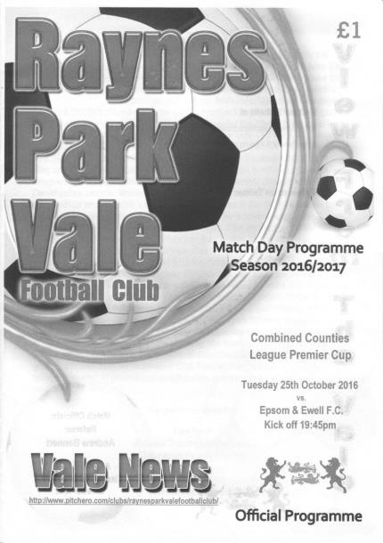
Late Ferdinando free kick secures a point for the Salts

Following our win over Bridon Ropes I thought we might be missing a player or two with injury. I certainly didn't expect that we would be confronted with five new absentees. Who'd be a Manager!

As a result it wouldn't be understating matters to say we went into this match somewhat light! Daryl Cooper-Smith, Rob Hendry and James Taylor were all away while Jason Nwachukwu had a groin strain and Adam Heagney had been called up to play for Leatherhead. With no Reserve team of course, this led to a situation where we only had two players on the bench and one of these, our regular keeper Michael Eacott, was only to be used as an outfield player as he recovered from a dislocated thumb after Saturday's match. It was just as well that we had signed a new player, Daniel Rose, a few days previously and as the game progressed he became more comfortable out there.

When you throw all of this into the mix, a draw at Raynes Park Vale doesn't look quite so bad, and it has to be said that a point was all we deserved from a match where the home side belied their lowly league position to get ahead and then chase everything down with an enormous amount of work rate. When you also consider the playing surface, which looked similar to how most pitches look in April, it was difficult to play our type of football even with five players strung across the midfield. In fact it was hard to tell at times whether it was 4-3-3 or 4-5-1 as we struggled to create much at all, particularly in the first half. Jordan Gallagher was entrusted with the 'one man up front' position but struggled in the unfamiliar role and didn't get a great deal of support. At times he appeared to be used as a false number nine as the two Matts, Ferdinando and Farrell often broke forward ahead of him.

Going up the hill we had a slow start and nearly conceded in the third minute when a 25 yard free kick was struck at goal. Ali Turpie was down to make the save but was unable to hold on to it and the loose ball was smashed against the woodwork from close range; the ball flying to safety. However, we didn't heed the warning and in the sixth minute a deep corner was met by a towering but unmarked header from Dan

Amaju to put the hosts ahead from close range.

In response Ferdinando saw his free kick deflected by the first defender for a corner, although this wasn't awarded because of an offside flag being raised, even though any player who may have been in an offside position was not directly involved as the ball clearly had no opportunity to get close to them. When will we get consistency on this issue?

We probably should have been level in the 15th minute when a deeper free kick from Ferdinando was met at the far post by Craig Hastings but he was unable to get his header on target and he then glanced a more difficult header just wide from an Agi Panayiotou on the half hour. Our first shots on target came towards the end of the half as Alex McKay tried to celebrate his 30th birthday with a 20 yarder but on each occasion he was a little off balance and the shots were easily gathered by Tony Davis.

Going down the hill at Grand Drive is an infinitely better proposition than the alternative and I felt that if we could improve then we would surely break through and turn this game around. We certainly improved and new boy Rose whipped in a right wing cross which Gallagher controlled and then set up Farrell on the edge of the area but his shot was deflected and the ball dribbled through to Davis.

We then nearly drew level in the 75th minute when a corner was met by a powerful downward header from Hastings, but the ball hit a defender's shin on the line and skewed off at an angle straight across the face of goal, just beyond the keeper's left hand post and out for another corner! Maybe it wasn't going to be our day and frustration grew when Gallagher took a free kick from a dangerous position only to see it blocked by the wall with Ferdinando, our best set piece taker in many years watching the action.

It was nearly 2-0 shortly afterwards when a home striker made a fine run, avoiding two challenges but they unbalanced him and by the time he reached Turpie he was unable to keep his shot on target and it went into the side netting. Fortunately there was time for one more chance as we earned another free kick on the edge of the area and this time Ferdinando took it and buried it low into the bottom corner and just inside Davis' left hand post with the clock on 92 minutes.

Going into this game I am sure many people will have looked at the league table and thought we would be fine. However, as we have learned over the years, league positions count for little and it's about who turns up on the day. Our fifth straight win at Grand Drive was not to be, but a late equaliser made it feel a little like a win, even though the table will say otherwise.

Epsom and Ewell: Ali Turpie, Reisse Griffin, Matt Tanton, Craig Hastings, Dan Dean (c), Alex McKay, Savvas 'Agi' Panayiotou, Matt Farrell, Jordan Gallagher, Daniel Rose, Matt Ferdinando

Subs: Charlie Clark-Gleave for Gallagher (86)

Club Records - 8th November
Date | Day | Competition |  | Opponents |  | Scorers
08/11/24 | Sat | Surrey Senior Cup 3q | A | Egham | 3-2 | R.Marlow (2), J.Parr
08/11/30 | Sat | Amateur Cup 3q | A | Mitcham Wanderers | 1-1+ | F.Behn
08/11/47 | Sat | London League | H | Tilbury | 0-1
08/11/52 | Sat | Corinthian League | H | Hounslow Town | 4-1 | B.Goddard (3), V.Honey
08/11/58 | Sat | Corinthian League | H | Maidenhead United | 2-1 | T.Millard, M.Carlson
08/11/69 | Sat | Surrey Senior Cup 2q | H | Ulysses | 1-0 | T.Seymour
08/11/75 | Sat | Athenian League 2 | A | Camberley Town | 3-3 | T.Tuite (2), P.Butler
08/11/80 | Sat | Isthmian League 1 | H | Chesham United | 0-2
08/11/86 | Sat | Isthmian League 1 | A | Maidenhead United | 0-1
08/11/88 | Tue | Isthmian League 2s | A | Eastbourne United | 3-5 | B.Perkins (2), C.Hadingham
08/11/97 | Sat | Isthmian League 3 | H | Southall | 6-0 | A.Rawlinson (2), A.Nimmo (2), A.Boxall, K.Webb
08/11/03 | Sat | Isthmian League 1s | H | Croydon | 1-2 | L.Purvis
08/11/08 | Sat | Combined Counties  Premier Division | H | Bedfont | 2-0 | L.White, R.Burns
08/11/14 | Sat | Combined Counties  Premier Division | A | Bedfont Sports | 2-0 | T.Smith (2)
Historical Decades
90 years ago – Epsom Town F.C.
06/11/26 | Sat | Surrey Senior Cup 3q | A | Addlestone | 4-1 | G.Armstrong, R.Coleman, R.Sperring (pen), R.Marlow
80 years ago – Epsom F.C.
07/11/36 | Sat | Amateur Cup 3q | A | Redhill | 0-3
70 years ago – Epsom F.C.
09/11/46 | Sat | London League | H | Bedford Town Reserves | 5-3 | G.Brogdale (2), S.Scott, E.Watkins, R.Bostock
60 years ago – Epsom F.C.
10/11/56 | Sat | Amateur Cup 3q | A | Ruislip Manor | 6-1 | R.Colfar (3), D.Hermitage, J.Sorensen, J.Bangs
50 years ago – Epsom & Ewell F.C.
05/11/66 | Sat | Athenian League 2 | H | Eastbourne | 6-3 | I.Skinner (3), T.Thomas (2), T.Williams
40 years ago – Epsom & Ewell F.C.
06/11/76 | Sat | Athenian League 1 | A | Ruislip Manor | 5-2 | T.Tuite (5)
30 years ago – Epsom & Ewell F.C.
08/11/86 | Sat | Isthmian League 1 | A | Maidenhead United | 0-1
20 years ago – Epsom & Ewell F.C.
09/11/96 | Sat | Isthmian League 3 | H | Harlow Town | 1-3 | A.Boxall
10 years ago – Epsom & Ewell F.C.
04/11/06 | Sat | Combined Counties  Premier Division | A | Bookham | 3-0 | J.Watson (2), A.Pero

History Corner – 8th November
92 years ago today we made our one and only visit to Manorcroft, the home of Egham F.C. for a Surrey Senior Cup tie. It was a feisty encounter and we had Tom Kirk sent off this day for retaliation after he was felled by an opposition player. This happened in the 36th minute and we trailed 2-1 at the half but turned it around and Reg Marlow who had earlier required treatment after a kick to the stomach returned to score the winner with a strike that went in off the bar, after good work by Jack Parr who had scored our equaliser. The following season Egham, who were no relation to the current club, had moved to Vicarage Road and Manorcroft was built on.

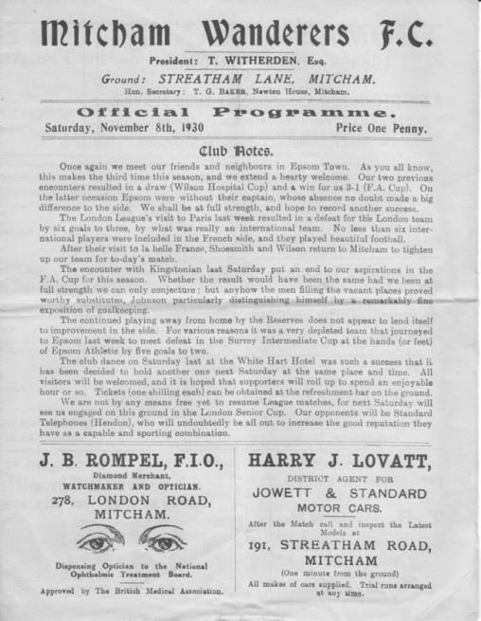
86 years ago today we visited Mitcham Wanderers in the Amateur Cup. (see programme pictured) We would eventually meet on seven occasions this term with two other scheduled minor cup meetings never taking place, and having been knocked out of the F.A. Cup there just three weeks previously a hostile home crowd of over 2,500 were expecting more of the same. The local papers described the match as "One of the hardest, closest and most exciting games in ages" but it would finish even after Freddie Behn put us ahead in the first half. The hosts equalised with a disputed penalty and it was too dark to commence extra time so a replay would take place the following week where we would prevail 5-1 in another controversial encounter.

60 years ago this week Ray Colfar, one of the best wingers we ever had, scored a hat trick at Grosvenor Vale as we crushed Ruislip Manor in an Amateur Cup tie. He would go on to have a fine career with Crystal Palace and Guildford City, also spending some time at West Ham United.

50 years ago this week Ian Skinner scored a hat trick for us in a heavy home win over Eastbourne, who would soon change their name to Eastbourne Town to avoid confusion with the United club that were also in this Division of the Athenian League. This match was only 1-0 at half time but by the end a further eight goals had been scored as we won 6-3 with Terry Thomas scoring twice and the other coming from Player / Manager Tony Williams.

40 years ago this week we went back to Grosvenor Vale again for another meeting with Ruislip Manor, this time it was an Athenian League fixture. We defeated them 5-2 on their own patch but receiving the majority of the praise was Tommy Tuite who scored all five goals for us that day. Nine years later he would do it again at Windsor & Eton, but this particular result helped us to promotion from Athenian League Division Two and further progress to the Isthmian League would then follow, so this was an important result.

10 years ago this week former Manager Lyndon Buckwell took charge of our boys for the first time against a Bookham team whose Manager was Glyn Mandeville! We were in the bottom two at the time of this match, which was played at Meadowbank, but an early goal keeping error gave Adam Pero an easy finish for the first goal and we would go on to win 3-0. Seven days later we defeated Cobham 3-0 at Merland Rise and all thoughts of relegation were banished. Lyndon would of course provide us with nearly eight years and over 500 games service as Manager.

From behind the goal
Guildford City 0-2 Epsom & Ewell
Combined Counties League - Premier Division - Saturday 5th November 2016

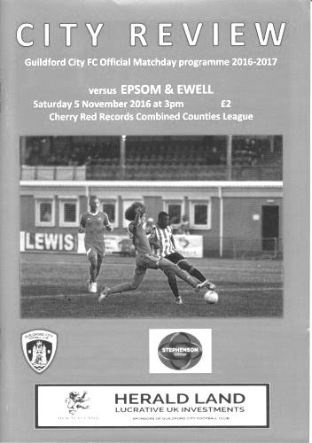
Hendry and Farrell put the gloss on a big team win at the Spectrum

After an eleven day break it was good to see a full strength squad of 16 players available for a very tough looking encounter at in form Guildford City with Rob Hendry, Daryl Cooper-Smith and Michael Eacott all returning after missing the Raynes Park Vale match. It was quite surprising to see big Mike back on the field so soon after dislocating his thumb in the Bridon Ropes Vase match just two weeks ago and he made a number of fine saves that helped to ensure that we returned home with all three points.

Despite being played on Bonfire night it must be said that there wasn't a lot of sparkle on show with both teams cancelling each other out for a great part of the match. There were also a number of stoppages for offsides, many of which were debatable. However, the game swung from end to end throughout the ninety minutes and the commitment from all of our players on show was total. It needed to be as the home side arguably had the better of things in the first half but crucially for them, weren't able to take their chances.

Eacott was busy as early as the fourth minute when Mario Embalo played the ball through to Shaun Lyle but his low strike was kept out for a corner. Within two minutes though we had two opportunities of our own with a corner reaching Dan Dean just a few yards out but he saw the ball late and it bounced off him. Then Matt Ferdinando intercepted a weak defensive header but his shot from the edge of the area was just over the bar. Such was the nature of this game that the home side then nearly scored again as a deep cross was headed goalwards at the far post but Eacott tipped the ball over for a corner.

I recall thinking at this point that it looked like this match might end up as a high scoring encounter as both teams looked like they could find the net at any time. The chances continued as Cooper-Smith sliced a difficult chance wide on the volley and then Hendry got through on goal from a great pass out of defence but his shot was weak and straight at Luke Badiali in the Guildford goal. within a minute Eacott was keeping out another low shot with his feet and then on the counter attack Agi Panayiotou did really well to dispossess Jacob Lambe who then pulled him down on the edge of the area to earn a yellow card. The free kick on the edge was in Ferdi territory but instead of burying the ball as he did at Raynes Park recently he was inches wide of the far post with his set piece.

We then witnessed a nasty collision between the keeper and Farrell as our man chased a through ball from Cooper-Smith and caught a stud in his face for his troubles, but fortunately was able to return to the fray after a bit of treatment. As the half closed we began to get on top and took full advantage in the first minute of injury time from an Alex McKay long throw

which was headed away to the edge of the area but Farrell was waiting. He beat his man but as the ball got away from him it fell nicely to Hendry who drilled it back across Badiali into the bottom corner.

The opposition started the brighter of the two teams in the second half and it looked as though it was going to be a long half for the travelling Salts contingent. A long range effort just clipped a defender on its way through, making the save a lot easier for the grateful Eacott but the pattern of the first half continued and we were soon on the counter attack with Cooper-Smith setting up Ferdinando whose shot from twenty-five yards out required a decent save to keep us from increasing our lead. In the 54th minute though we were slow to react and a good run and shot required Eacott to tip the ball around the post for a corner, earning our players a telling off from Assistant Manager Matt Smith, in charge for the absent Glyn Mandeville.

And I'm pleased to report that the warning was heeded. From this point we improved and the home team's threats became fewer. We had a shout for a penalty when Hendry got on to a good ball just ahead of Badiali and fell under his challenge but there appeared minimal contact and it was not enough to impress the referee. McKay was next to try his luck after a Panayiotou free kick caused panic in the Guildford area but was just wide of the far post from 12 yards.

Cooper-Smith earned himself an unnecessary yellow card for disputing an offside when he was at least two yards ahead of the last man but we continued to press for a second goal, only to see another last gasp clearance after the ball had bounced around in the box for a while. Then Ferdinando produced a great crossfield ball to Hendry but with no one in the centre he went for goal from 25 yards, just missing the near post. Moments later Ferdinando was the recipient of an equally impressive long pass from Craig Hastings but he was unable to get a shot away; the loose ball falling to Reisse Griffin who sent it high and wide from 25 yards. With quarter of an hour remaining Hendry saw his shot blocked but the loose ball fell to McKay whose volley was only just over the bar and from another good Panayiotou free kick Farrell was there first but his looping header was tipped over by the stretching Badiali.

We were well on top by now and our substitutes both had opportunities. Jason Nwachukwu found his shot blocked by the feet of Badiali and with a couple of minutes remaining Jordan Gallagher fired into the side netting from a narrow angle after a left wing cross had been flicked on by a defender. However, with the clock showing the 89th minute we finally got the second goal that our efforts by then deserved as Gallagher got away down the right. his cross was palmed away by the keeper but the ball fell to Farrell just ten yards out and he had time to control the ball first before crashing the ball into the net.

In summary, this was a match we could easily have lost against a Guildford City team that had only lost once in their previous eleven encounters but by the end we had covered every inch of the pitch and snuffed out the home side's threat entirely. On that basis alone we were deserving of the three points on offer.

Epsom and Ewell: Michael Eacott, Reisse Griffin, Matt Tanton, Craig Hastings, Dan Dean (c), Alex McKay, Matt Ferdinando, Savvas 'Agi' Panayiotou, Daryl Cooper-Smith, Matt Farrell, Rob Hendry

Subs: Jordan Gallagher for Ferdinando (71), Jason Nwachukwu for Panayiotou (78),
Daniel Rose for McKay (91)

Centre page for results

Centre page for results


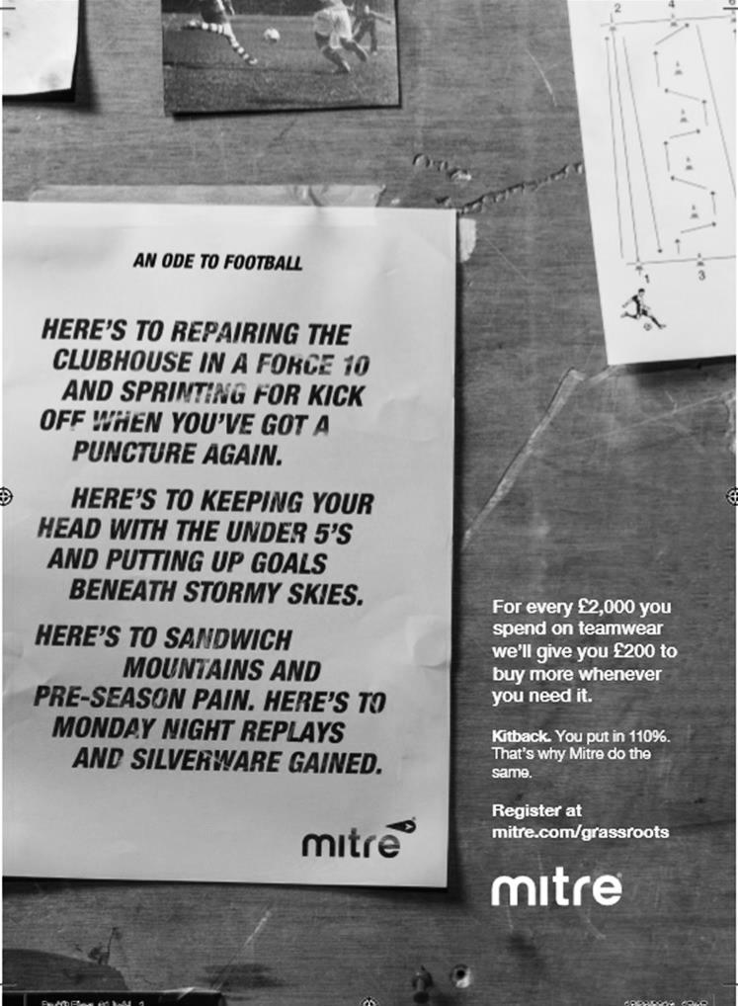

Sutton Common Rovers F.C. – History
Chairman and Life President Alan Salmon founded SCR F.C in 1978, when the club began life as INRAD FC, based in Carshalton. The club entered a new era when Alan moved to Sutton and arranged sponsorship with his new neighbour, CENTRE 21 FC was born. This era saw the club running one Saturday side, three Sunday sides and three Youth sides. Centre 21's sponsorship continued until the club's youth players were no longer under 21 years old.

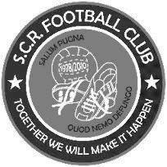
The club again sought a new identity; SUTTON COMMON ROAD FC was formed and subsequently abbreviated to SCR FC. Since then the club has had five major sponsors whose names have been incorporated into the clubs affiliated name: SCR PLOUGH (twice), SCR GRAPES, next the club's longest sponsor SCR LITTEN TREE (7 years) & finally SCR Kingfisher, Ewell with whom we started our venture in Saturday football in 2004/05.

It was at this point that the club took the decision to revert back to using the SCR name alone, feeling that as we strive for continued promotion we needed to disassociate ourselves with the whole ‘pub team’ image. The club however did take sponsorship from the Fox & Hounds, Carshalton for the Saturday first team in 2006/07, but the decision was made that the pub name would not be incorporated into our own, for the above reason.

The club entered yet another new era this season, with the introduction of a third Saturday side (Messers Alex Avis & Tony Williams) and the 1’s moving to the Middlesex County FL (and a name change SUTTON COMMON ROVERS) in the pursuit of combined Counties football, having made an unsuccessful application from the Surrey South Eastern Combination at the end of season 2006/07 having finished joint top (3rd on goal difference… -1 goal)

A third place finish in the Middlesex County League Premier Division in 2007/08 meant that our promotion to the CCL was not assured but months of hard work & determination from the management team SCR eventually secured a place for the clubs first time in their 30 year history at the league AGM in June 2008 and the reserves joined the CCL Reserve Division under the guidance of Alex Avis & Justin Salmon.

Season 2008/09 saw the latest name change of the club, the inclusion of “MOLE VALLEY” to form our current name, MOLE VALLEY SCR FC reflecting the area in which we played after migrating from the London Borough of Sutton. Season 2009/10 saw the club reach a Surrey Cup final, narrowly being defeated by Sutton United on penalties after a 1-1 extra time draw and in the same season compete in the F.A. Vase for the first time in our relatively short history.

We finished Champions of Division One (playing out of Cobham FC after we lost our ground two weeks before the start of the season) at the second time of asking, narrowly pipping Worcester Park to the post in a fine run which saw us finish three points clear on the final match of the season, assuming as we believed, that we were awarded the points from the postponed Coulsdon match who unfortunately were unable to field a side for our scheduled league game some weeks earlier.

The following season saw the club play at our highest level to date, and make our F.A. Cup debut, although this lasted just one game and ended in a 5-0 defeat against Chertsey Town.

The club managed two seasons in the Premier Division, before being relegated back to Division 1, following a start to the season that contained 12 straight league defeats.

The 2012/13 season started with a rebuilt side and expectations of consolidation, however a 20 game unbeaten run propelled us into runners up spot, and a much coveted promotion back to the Premier Division. 2013/14 started brightly, but went to the last game, and a point earned survival. It was the same last season, and although we lost to Guildford City, we still managed to survive.

In 2015/16 the club changed its name back to Sutton Common Rovers, and after much hard work by The Salmons, a return to Sutton to ground share with Sutton United was arranged. The club reached the Fourth Round of the F.A. Vase before defeat at eventual semi-finalists Bowers & Pitsea. A run of five league defeats from January to April left the club threatened with relegation but managed to finish 19th and ensure another season in the Combined Counties Premier Division.

Surrey Senior Cup
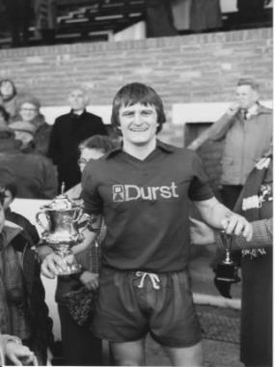
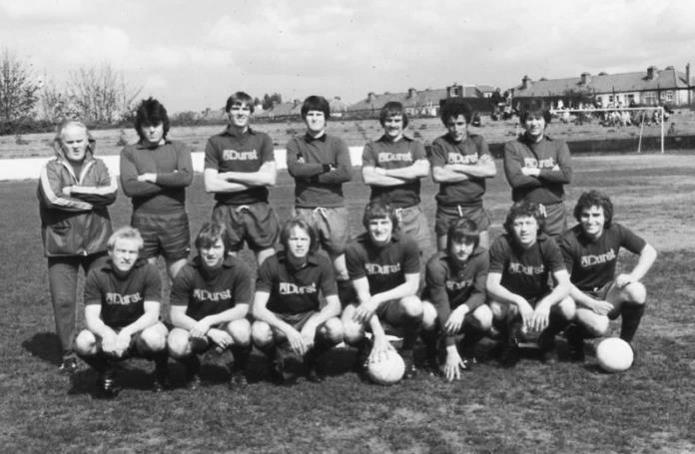
First Round
Abbey Rangers | 4-3 | AFC Croydon Athletic
Whyteleafe | 5-4 | Westfield
Second Round
Met Police | 15/11 | Kingstonian
Ashford Town (Mx) | 15/11 | Knaphill
Woking | 1/12 | Walton Casuals
Whyteleafe | 6/12 | Colliers Wood United
Guildford City | 30/11 | Horley Town
Egham Town | 15/11 | Corinthian Casuals
Godalming Town | 6/12 | Merstham
Molesey | 1/12 | Leatherhead
Raynes Park Vale | 6/12 | Sutton United
Sutton Common Rovers | 28/11 | Camberley Town
Dorking Wanderers | 6/12 | South Park
Badshot Lea | 29/11 | Farnham Town
Walton & Hersham | 1/12 | Croydon
Carshalton Athletic | 1/12 | Tooting & Mitcham United
Chertsey Town | 29/11 | Abbey Rangers
Epsom & Ewell | 6/12 | Chipstead

Every Opponent A-Z
Over the years we have played many, many different opponents. Exactly how many is a difficult question, as it all depends on your definition. Are Camberley & Yorktown different to Camberley Town, or are Epsom Town different to Epsom F.C. or Epsom & Ewell F.C.?

In my analysis I have classed both of the above examples as the same team, and will work through them all from A to Z. Some we have played many times, whilst others we have met just once or twice. Enjoy!
Sutton United: Played 38 - W9 D6 L23 - F58 A93 - PPG - 0.87 - Awful

We have met our local rivals frequently over the years, although maybe not quite as often as you might think. In fact, whilst friendlies during the season were an integral part of the fixture calendar back in the day, and were included in official club stats from that period, many were arranged between the clubs towards the end of the season as was the case back in our first Senior season of 1924/25 when we played on consecutive Saturdays, losing both times.

They were the first team to beat us in a competitive encounter at West Street in the Amateur Cup on 10th October 1925 by a goal to nil, although in October of 1927 we gained revenge by dumping them out of the F.A. Cup there by two clear goals, scored by Reg Marlow and Freddie Behn.

A season later we lost on our first Senior visit to Gander Green Lane, again in the Amateur Cup, although this was a controversial matter. After having lost 3-2 our club protested on the basis that two Sutton players were also playing Sunday football, almost a hanging offence back then. We lost the appeal though and received some fairly bad press for appealing in the first place, although it would come back to bite Sutton also as they progressed in the competition. They survived another appeal from Leytonstone in the last 16 but a further appeal from Ilford after Sutton had beaten them in the Quarter-Final proved their undoing!

It made for a heated atmosphere and an unpleasant game when the teams next met in October of 1930 at West Street in the F.A. Cup and our Captain George Mackesy was sent off along with Sutton’s Lever. The Surrey Comet’s reporter advised that: "Mackesy and Lever had a "difference of opinion" which led the referee to require them to leave!"

We met on four occasions during 1932/33, winning all of them. Two were friendlies but the others were wins in the Amateur Cup and also a 3-2 win in the Surrey Charity Shield at Gander Green Lane on 14th January 1933. So, if you are keeping count, you will note that we held a 4-2 lead in competitive matches to that stage, which was quite impressive against an Athenian League team. However, things didn’t go that well from this point onwards. Two further away defeats in Surrey Charity Shield games were added to by a 1937 home 2-4 F.A. Cup defeat and after the war things continued with another F.A. Cup defeat, this time in a replay after a 2-2 draw after extra time at West Street.

Despite meeting certain clubs regularly in the Surrey Senior Cup like Dulwich Hamlet and Corinthian Casuals, we didn’t meet United until 1957 when goals from Johnny Bangs and former Sutton player Jorgen “Jan” Sorensen ensured a 2-0 home win. Our next meeting would also come in this competition but it would be a further twenty-four years later when we drew 0-0 there in a Semi-Final in March 1981. Sutton were arguably preoccupied with a trip to Wembley for the F.A. Trophy Final but we were a good team ourselves that season and won the replay 3-2 at West Street in a topsy-turvy match. This enabled us to play and defeat Woking in the Final who we defeated 2-1 at Sandy Lane to win the trophy for the first and so far, only time.

However, revenge was gained in this competition in both 1983 and 1984. They defeated us 2-1 on 8th January 1983 on my first ever visit to Gander Green Lane and the following year beat us 4-0 in the Cup Final at Imber Court. Arguably, it was our turn to be preoccupied that day with a promotion challenge and within a few days this was confirmed.

Of course this meant that we would play them in the League as equals. Not with great success admittedly, but we were competitive. Our first League meeting came on 11th September 1984 and when we trailed 4-2 we feared the worst, but fought back in the second half to make it 4-4 with just minutes remaining. Long enough however for a speculative 25 yard attempt to loop off the back of Mick Stratford and result in a fluky winner! They won the return match 2-1 in front of over 600 at West Street on Boxing Day 1984 and we were to meet twice more in the Surrey Senior Cup Quarter-Final, drawing 0-0 at Gander Green Lane on the Tuesday 26th February but having little time to celebrate the achievement as we lost 4-1 in the replay just two days later at West Street.

The 1985/86 season was more difficult as they would be Champions and we would finish bottom of the table, but we still got a draw from them on 5th November 1985 at West Street thanks to a cracking strike from Kevin Duffell who saw his free kick blocked back to him so lashed it into the net from twenty yards with his weaker, right foot. I was behind the goal that day and it remains one of my clearest memories over thirty years on! Unfortunately we would lose 3-1 in the return match in December 1985 despite a Tommy Tuite goal bringing us level at half time.

So the League meetings were over and our remaining four encounters have come in the County Cup. The first of these was a Semi-Final in March 1987 but we were outclassed 5-0. This was the fourth time in five years that they had knocked us out of this competition.

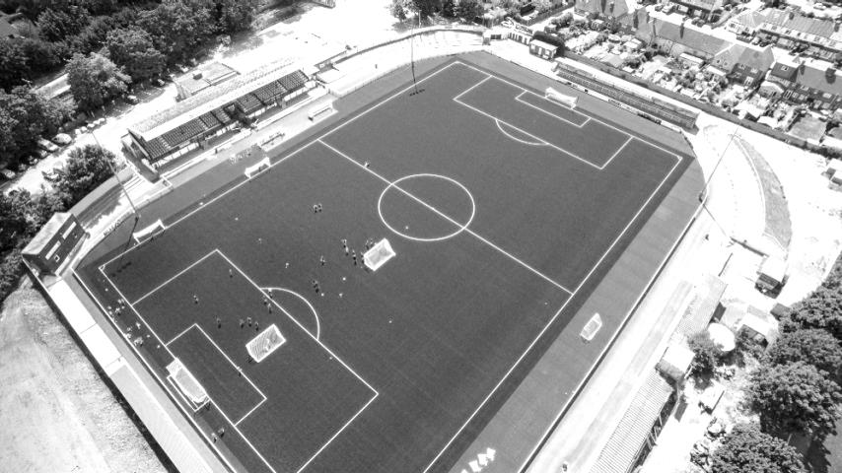
We had our chances in the next match in December of 1992 but subsided 2-0 at Gander Green Lane but that was our last meeting until the 9th December 2008. This was a famous day in our history as we led through a brilliant Kyle Hough goal that would win goal of the season that year, although a header brought them level by half time and when they went ahead early in the second half, it didn’t look good. However, they didn’t get a third and when Dale Marvell broke away to score an equaliser with ten minutes remaining it was incredible. It then became unbelievable as he scored an almost identical goal just four minutes from time and we held on to win 3-2!! Despite that achievement it was back to the usual results when we next met as they edged us out 1-0 in December 2011 in a match played at Merstham’s Moatside ground.

We remain the “little brother” in the relationship and probably always will be, regrettably.

Left: The Borough Sports Ground at Sutton United complete with its new 3g Astroturf surface

Combined Counties League Premier Division Opponents
All-time Records
incl Saturday 5th November | P | W | D | L | F | A | PPG | GD | Best  Win | Worst  Loss
Abbey Rangers | 2 | 2 | 0 | 0 | 8 | 1 | 3.00 | +7 | 7-1 | X
Bedfont & Feltham | 1 | 1 | 0 | 0 | 9 | 2 | 3.00 | +7 | 9-2 | X
Spelthorne Sports* | 5 | 4 | 1 | 0 | 15 | 6 | 2.60 | +9 | 6-2 | X
Sutton Common Rovers | 10 | 8 | 1 | 1 | 27 | 12 | 2.50 | +15 | 4-0 | 1-4
Horley Town | 29 | 20 | 5 | 4 | 65 | 30 | 2.24 | +35 | 6-0 | 1-3
Colliers Wood United | 22 | 14 | 2 | 6 | 45 | 33 | 2.00 | +12 | 4-0 | 0-5
Westfield | 19 | 11 | 3 | 5 | 40 | 31 | 1.89 | +9 | 6-1 | 0-4
Bedfont Sports | 9 | 5 | 2 | 2 | 13 | 10 | 1.89 | +3 | 3-0 | 0-4
Farnham Town | 14 | 8 | 2 | 4 | 25 | 23 | 1.86 | +2 | 3-1 | 1-4
Knaphill | 7 | 4 | 1 | 2 | 15 | 8 | 1.86 | +3 | 4-0 | 1-2
Guildford City | 17 | 10 | 1 | 6 | 34 | 22 | 1.82 | +12 | 5-1 | 1-5
Hanworth Villa | 15 | 8 | 3 | 4 | 38 | 26 | 1.80 | +12 | 5-0 | 1-4
Raynes Park Vale | 27 | 13 | 6 | 8 | 58 | 37 | 1.67 | +21 | 6-1 | 0-2
Badshot Lea | 18 | 8 | 3 | 7 | 35 | 34 | 1.67 | +1 | 4-1 | 0-4
Walton & Hersham | 50 | 24 | 10 | 16 | 101 | 97 | 1.64 | +4 | 6-0 | 0-8
Camberley Town* | 89 | 38 | 22 | 28 | 158 | 123 | 1.52 | +35 | 9-1 | 0-4
Hartley Wintney | 10 | 4 | 3 | 3 | 25 | 17 | 1.50 | +8 | 5-0 | 2-4
Windsor | 48 | 18 | 12 | 18 | 88 | 90 | 1.38 | -2 | 4-0 | 0-6
Chertsey Town | 47 | 17 | 5 | 25 | 70 | 86 | 1.19 | -16 | 3-0 | 0-7
AFC Hayes | 8 | 2 | 2 | 4 | 16 | 15 | 1.00 | +1 | 7-0 | 0-3
North Greenford United | 11 | 3 | 2 | 6 | 15 | 20 | 1.00 | -5 | 3-0 | 1-4
CB Hounslow United | 2 | 0 | 0 | 2 | 2 | 7 | 0.00 | -5 | X | 1-5
* includes one abandoned match v Camberley and one loss on penalties v Spelthorne

EL Records Premier Challenge Cup
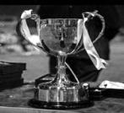
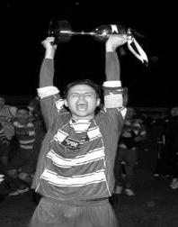
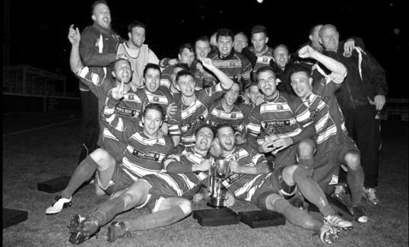
First Round
Redhill | 4-0 | Bedfont & Feltham
Match played at Bedfont & Feltham F.C.
Spelthorne Sports | 1-4 | Sutton Common Rovers
Knaphill | 0-2 | Camberley Town
Worcester Park | 2-1 | Dorking
Epsom & Ewell | 1-0 | Abbey Rangers
Westfield | 3-2 | North Greenford United
Cobham | 3-2+ | Bagshot
CB Hounslow United | 3-4 | Farnham Town
South Park Reserves | 1-4 | Balham
Second Round
Hanworth Villa | 2-4+ | Epsom and Ewell
AFC Hayes | 3-4 | Balham
Epsom Athletic | 1-5 | Windsor
Sutton Common Rovers | 14/11 | Bedfont Sports
Raynes Park Vale | 2-0 | Colliers Wood United
Frimley Green | 1-2 | Banstead Athletic
Westfield | 8-4+ | Redhill
Staines Lammas | 0-1 | Farnham Town
Worcester Park | 19/11 | Cove
Badshot Lea | 0-5 | Guildford City
Chertsey Town | 1-2 | Camberley Town
Cobham | 1-3 | Chessington & Hook United
Hartley Wintney | 4-0 | AC London
Horley Town | 2-2+ | Sheerwater
Horley Town won 5-4 on penalties
Walton & Hersham | 5-1 | Eversley & California
Ash United | 2-0 | Farleigh Rovers
Third Round
Banstead Athletic | V | Westfield
SCR / Bedfont Sports | V | Walton & Hersham
Farnham Town | V | Camberley Town
Ash United | 0-2 | Windsor
Raynes Park Vale | 2-1 | Hartley Wintney
Guildford City | 2-1 | Balham
Horley Town | 2-0 | Chessington & Hook United
Worcester Park / Cove | V | Epsom & Ewell

Player Sponsorship
Here is the current list for the 2016/17 season showing all of our players and Management that are currently available for sponsorship.

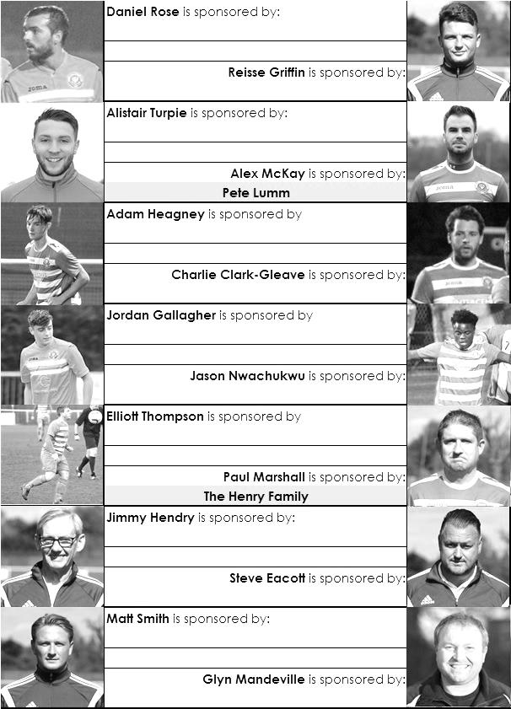

Sponsorship costs just £40 and it is easy to do. Just select a player who has not been previously sponsored and let a Committee Member know that you would like to sponsor them. Beware though. Until we have received the money it is possible for someone to jump in front of you, so don’t delay, sponsor today!
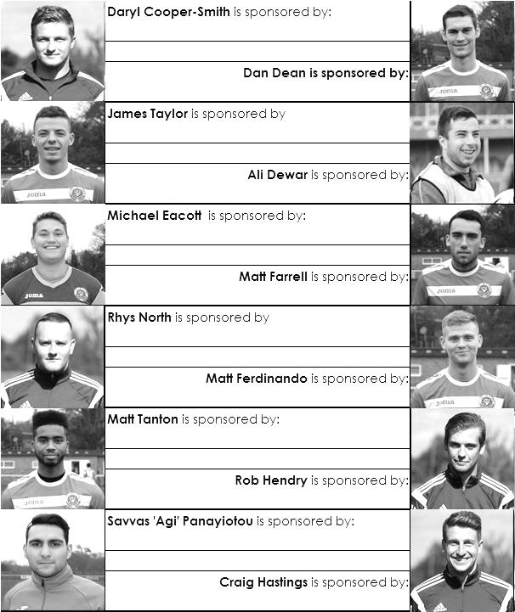

Match and Ball Sponsorships – 2016/17
Opponent | Date | Match Sponsor | Ball Sponsor
Gravesham Borough | 07/08/16 | Club President - Stella Lamont
Gravesham Borough | 07/08/16 | Relocation Committee Member - Mike Lovett
CB Hounslow United | 16/08/16 | EEFC Management Committee
Abbey Rangers | 23/08/16 | Steve & Geoff Dyke
Horley Town (11.30am) | 29/08/16 | In Memory of Chris Henry
Abbey Rangers (LC) | 06/09/16 | Paul Merritt
Camberley Town | 10/09/16 | Building Shop Ltd
Knaphill | 24/09/16 | EEFC Holding Company Director – Pete Lumm
Bridon Ropes (FAV) | 22/10/16 | George and Joseph Saunders
Sutton Common Rovers | 08/11/15 | Alex McKay Senior
Abbey Rangers (FAV) | 13/11/16 | EEFC Holding Company Director – Dave Ellins
Windsor | 15/11/16
Bedfont Sports | 19/11/16
AFC Hayes | 26/11/16
Chipstead (SSC) | 06/12/16
Hanworth Villa | 13/12/16
Chertsey Town | 17/12/16
Raynes Park Vale (11.30am) | 27/12/16
Spelthorne Sports | 07/01/17
Guildford City | 17/01/17
Bedfont & Feltham | 21/01/17 | Programme Editor - Richard Lambert
Badshot Lea | 04/02/17
Westfield | 18/02/17
Walton & Hersham | 04/03/17
Hartley Wintney | 18/03/17
Farnham Town | 25/03/17
Colliers Wood United (1pm) | 14/04/17 | Good Friday match – make a note!
North Greenford United | 22/04/17 | Club President - Stella Lamont
For League, League Cup and Surrey Senior Cup Matches:
Match sponsorship - £40.00 Match ball sponsorship - £25.00. Combined £55.00.
For F.A. Cup and F.A. Vase matches:
Match sponsorship - £50.00 Match ball sponsorship - £30.00. Combined £65.00.

Sponsorship includes: (x2 for match, x3 for match and ball)

Admission, programmes, hospitality and advertising and mascot for the day (if required).
If you are interested, just speak to a Committee Member, or drop me an email at: richard.c.lambert@gmail.com


We also thank our Kit Sponsors INTERCEM

Salts Super Six Predictor
The Salts Super Six Predictor is live again for today’s match and the tickets are on sale at today’s game to the left of the gate.

The competition is easy to play! To win, you simply need to predict the results of six matches correctly from the three options, fill in the form and make sure it is back with our seller before the deadline on the ticket. The latest fixtures are shown below.

If you are a club regular, you just need to place your name on the sheet, although if you aren’t, then we’ll need a contact number from you too. We will announce any winners on the website within three working days, so don’t worry, we won’t miss you!

We had a big jackpot winner last year and it is getting quite large again! It is currently £273 and you’ll always know the size of the pot before you enter.

Please note that if there is more than one winner, the prize pot would be shared between the winners. All you need to do now is have a go, as many times as you like!

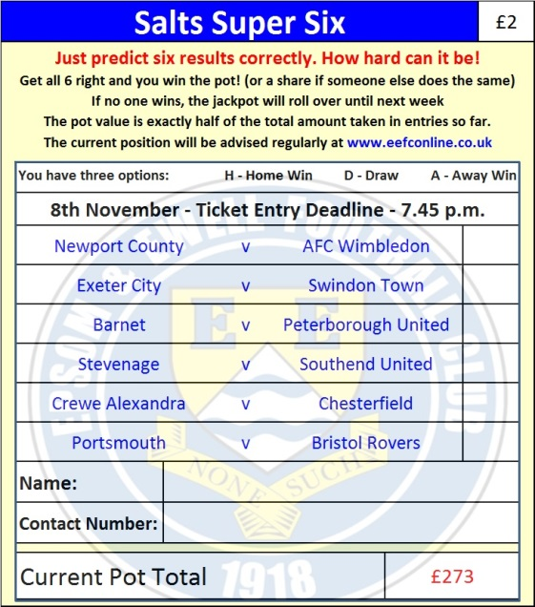

Good luck!

Combined Counties League – Premier Division
Tuesday, 8th November 2016 - Kick-off 7.45 p.m.
Epsom and Ewell  (Royal Blue & White hoops) | V |  | Sutton Common Rovers  (All Red)
Squad | NUMBERS
Michael Eacott |  |  | Leigh Bowden
Adam Heagney |  |  | Ollie Ellaway
Matt Tanton |  |  | Nehemiah Adams
© Dan Dean |  |  | Miguel Anderson
James Taylor |  |  | Aaron Bogle
Alex McKay |  |  | Sean Bradley
Reisse Griffin |  |  | Michael Campbell
Matt Farrell |  |  | Davis Cofie
Daryl Cooper-Smith |  |  | Anson Cousins
Matt Ferdinando |  |  | Owen Davies
Jordan Gallagher |  |  | Charlie Emery
Savvas ‘Agi’ Panayiotou |  |  | Danny Dernandez
Craig Hastings |  |  | Elton Gjoni
Jason Nwachukwu |  |  | Liam Holden
Daniel Rose |  |  | Richard Monan
Charlie Clark-Gleave |  |  | George Murphy
Alistair Turpie |  |  | Matt Robinson
Rob Hendry |  |  | Andrew White
Matt Smith
Glyn Mandeville | MANAGER |  | Darren Salmon
Matt Smith | ASSISTANT |  | Donovan Rennalls
Steve Eacott / Alex McKay / Jimmy Hendry | COACHES / PHYSIO |  | Guy Paul / Geoff Moxey /  Brent Wallage
REFEREE: C.Williams
ASSISTANTS: W.Ingram, L. Torz-Brown
Today’s Match and Match Ball are sponsored by Alex McKay Senior

OUR NEXT VISITORS TO HIGH ROAD
Abbey Rangers
Buildbase F.A. Vase – Second Round
Sunday 13th November 2016 – 3.00 p.m.

